**HARSHTON SCHOOL – MBALE**

**TERM ONE HOLIDAY PACKAGE-2023**

**PRIMARY TWO ENGLISH**

**Pupil’s Name: …………………………………………………………….**

1. **Fill in the missing letters.**
2. B____dge
3. ____niform.
4. Hos___ital.
5. **Write in ABC order.**
6. hen, food, egg, gate.

………………………………………………………………………………………………………………….

1. pencil, orange, net, mat.

………………………………………………………………………………………………………………….

1. ball, box, bim, bell.

………………………………………………………………………………………………………………….

1. **Use “is” / “are”.**
2. My mother ………………………………………………cooking food.
3. The pupils …………………………….…………….. writing the work.
4. What …………………………………….. you doing?
5. **Name these pictures.**

|  |  |  |  |
| --- | --- | --- | --- |
|  |  |  |  |
|  |  |  |  |

**(table, flower, flag, hut)**

1. Use **“Yes, they are”** and **“No, they are not”** correctly.
2. Are these balls?

………………………………………………………………………………………………………………….

1. Are they desk?

………………………………………………………………………………………………………………….

1. **Choose the correct word from the brackets.**
2. Darius did not carry his ……………………………………… **(bug, bag)**
3. The ………………………………………… today is bright. **(sun, son)**
4. Debrorah has ten ………………………………….. **(figures, fingers)**
5. Aunt is ……………………………………mother’s car. **(riding, driving)**
6. **Read the sentences and draw correctly.**

|  |  |
| --- | --- |
|  |  |
| She is carrying baby. | I am washing utensils. |

1. **Circle the odd one out.**
2. mother, father teacher, brother.

………………………………………………………………………………………………………………….

1. red, pen yellow, blue.

………………………………………………………………………………………………………………….

1. **Give the plural form of the underlined words.**
2. This is my book.

………………………………………………………………………………………………………………….

1. Our teacher is very rich.

………………………………………………………………………………………………………………….

1. **Form any four correct sentences from the table below.**

|  |  |  |
| --- | --- | --- |
| I  We  John  They  He | has  have | a nice bag.  five teachers in primary two.  a school van.  a toy car.  new teachers at school. |

**Sentences.**

1. ………………………………………………………………………………………………………………
2. ………………………………………………………………………………………………………………
3. ………………………………………………………………………………………………………………
4. ………………………………………………………………………………………………………………
5. ………………………………………………………………………………………………………………
6. 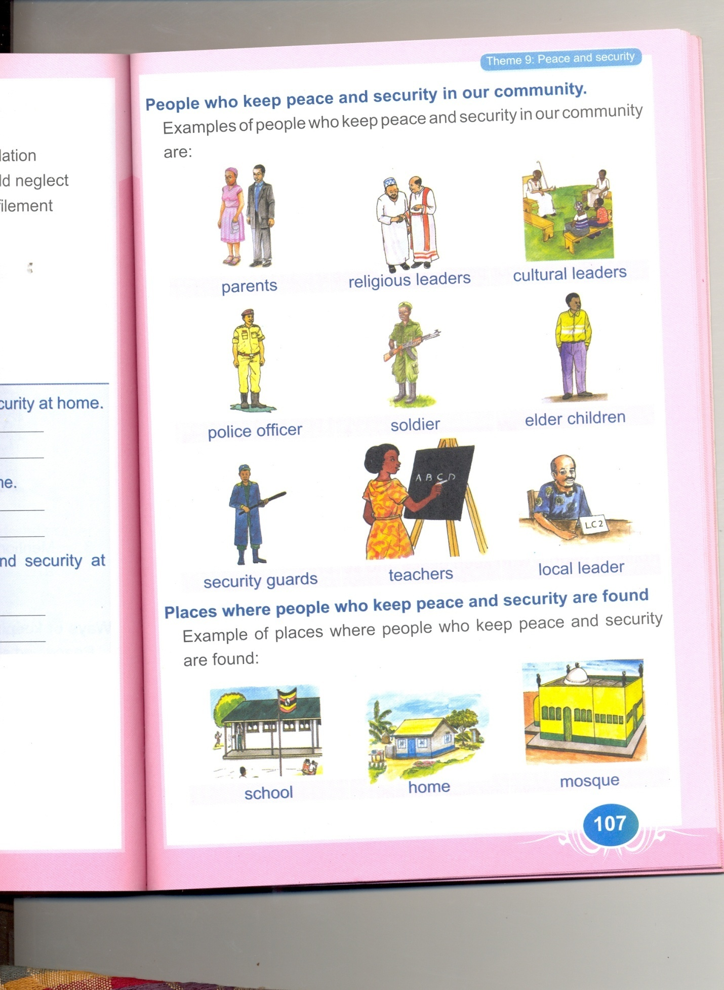**Complete the story using the words below.**

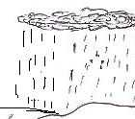It was Tuesday morning when Joshua was going to

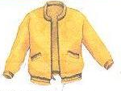 ………………………………..It started ………………………………. His mother told him to go with an ……………………….… and a ………….……………….…to school. Joshua went and entered the school

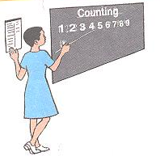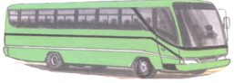 ……………………………… but he reached school late because of the rain. The ……………………………… was already in class teaching.

1. **Read the story and in full sentences answer questions that follow.**

Last Sunday morning, my father told me that we were going to visit our grandmother. We used a car to go to the village. On the way, we saw many bicycles, buses, motorcycles and lorries moving to different places. We passed near a lake and saw boats and ships sailing on water.

**QUESTIONS:**

1. Write the title of the story?

…………………………………………………………………………………………………………….

1. Who told them to go to the village?

…………………………………………………………………………………………………………….

1. Mention any three means of transport in the story.

…………………………………………………………………………………………………………….

1. Draw boats sailing on the lake.
2. **Write these sentences correctly.**
3. a knife This is

………………………………..……………………………………………………………………………….

1. balls are Those

………………………………………………………………………………………………………………….

1. **Punctuate the following.**
2. a ruler is broken.

…………………………………………………………………………………………………………

1. Today is friday.

…………………………………………………………………………………………………………

1. That is lans book.

…………………………………………………………………………………………………………

1. how old are you.

…………………………………………………………………………………………………………

1. **Count and write the number in words.**



1. Here are ______________ chairs.
2. 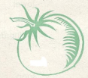 This is _______________ ruler.



There are ______________ tomatoes

**HARSHTON JUNIOR SCHOOL – MBALE**

**PRIMARY TWO – HOLIDAY PACKAGE-2023**

MATHEMATICS.

**Pupil’s Name: …………………………………………………………….**

**SECTION A (40 MARKS)**

|  |  |  |  |
| --- | --- | --- | --- |
| 1. | Fill in the missing numbers.  100,101,102,____,____, 106. | 2. | Write 4 in words.  ______________________ |
| 3. | Draw a set symbol for intersection. | 4. | Multiply: 2 x 3 = _______  + |
| 5. | Show 2 3 0 on the abacus below.  H T O | 6. | What is the time on the clock face below?  It is _____________ o’clock |
| 7. | Shade AuB  A B | 8. | Take away  8 – 2 = _________ |
| 9. | Join these sets to form one set    + = | 10. | Write the place value of the underlined digit.  2 4 6  __________________ |
| 11. | Divide/ share.  6 ÷ 2 = _____ | 12. | Fill in the correct number.    + = _____  _____ + _____ = ______ |
| 13. | One hand has five figures, how many figures do 2 hands have.  _____________________ | 14. | Arrange from the smallest  3, 5, 4, 2  ___________________ |
| 15. | Subtract  **Tens Ones**  4 2   * 2 1 | 16. | Tick the smaller number  7 or 2 |
| 17. | Write correctly  tse _________________ | 18. | Name the figure below.  ______________ |
| 19. | Write the number that comes before and after.  ______, 10 20, ______ | 20. | How many sides has the figure below have. |

**SECTION B (60 MARKS)**

|  |  |  |  |
| --- | --- | --- | --- |
| 21. | Name these shapes below.  **(Square, rectangle, triangle)**  **(2 marks each)** | b) | What is the standard unit for length.  _____________________  **(metre, grams)**  **(2 marks)** |
| 22. | Match numbers to their names.  10 six  6 three  3 ten  **(2 marks)** | 23.  a)  b) | Set A = { a, b, c, d}  B = { a, e, i, o, u}  How many members are in set B? **(2 marks)**  _________________________________  Find A∩B **(2 marks)**  __________________________________ |
| 24. | Write **two** things found on a coat of arm.   1. _______________ 2. _______________   **(2 marks each)** | 25. | Compare using **smaller** or **bigger.**  5 is ________________ than 3.  10 is ______________ than 20  **(2 marks each)** |
| 26. | Name the shaded part.  P Q  **(2 marks)** | 27. | Fill in the missing number.    + 4 = 7  **(2 marks)** |
| 28.  a) | Compare using **bigger** and **smaller**  **B**  **A**    Pot A is __________ than pot B.  Pot B is __________ than pot A.  **(2 marks each)** | b) | Compare using less or more.  **X Y**  a a  b b  c  d  Set X has ______ members than Y.  Set Y has ______ members than X.  **(2 marks each)** |
| 29.  a)  b) | Fill in the missing hundreds, tens, and ones.  245 = ___ hundreds, ____ tens, _______ ones.  ____ hundreds, _____ tens and ____ ones= 94.  **(2 marks each)** | 30.  b) | How many days are there in one week?  _______________________  **(1 mark)**  Write **two** days of the week that begin with letter T.   1. _________________ 2. _________________   **(2 marks each)** |
| 31 | Study the shopping list and answer the following questions.  One book at shs. 500  One pen at shs. 400  A ruler at shs. 200  **Questions.**  How much is a book?  ____________________  Which item costs shs. 200?  _____________________  How much does a pen cost?  ______________________  **(2 marks each)** | 32. | Study the graph below and answer the questions.   |  |  |  |  | | --- | --- | --- | --- | |  |  |  |  | | **Musa**  **Joy**  **Sum**  **Tom** | | | |   Musa got ___________ balls.  How many balls did Tom get?  _________________________  Who got one ball?  _________________________  Joy got __________ balls.**(2 marks each)** |

**HARSHTON JUNIOR SCHOOL – MBALE**

**TERM ONE HOLIDAY PACKAGE-2023**

**PRIMARY TWO READING**

**Pupil’s Name: …………………………………………………………….**

**Fill in the missing letter.**

sch__ __l m__ __ n c __ __k.

f __ ___ d d __ __r r __ __f

1. **Write these words correctly.**

chertea ……………………………………………

oodctr ……………………………………………

oock ……………………………………………

man police …………………………………………

1. **Complete the table correctly.**

|  |  |  |  |  |
| --- | --- | --- | --- | --- |
| **a** | **e** | **i** | **o** | **u** |
| bla | …… | bli | blo | blu |
| sha | she | shi | …… | shu |
| …… | tre | tri | tro | tru |
| cha | che | …… | cho | chu |

1. **Read and match correctly.**

garden tools shirts, blouses , pants

birds cows, goats, lions

clothes hoes, panga, slasher

animals dolls, toys, ball

play objects hens, ducks, turkey

1. **How many are these?**

These are ………………………… cups.





These are ……………………….… sticks.





 These are…………………chairs.



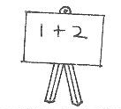



These are ………………black boards.

 These are …………………………rulers.

1. **Form small words .**

classroom ……………………………………………………

shopkeeper ……………………………………………………

door mat ……………………………………………………

bread ……………………………………………………

1. **Arrange words and form correct sentences.**

cooking food My mother is

……………………………………………………………………

pupils teaches teacher A

……………………………………………………………………

gives us milk A cow

……………………………………………………………………

1. **Tick parts of our body.**

bench stool tree head

mouth mango pen chalk

house compound leg tin

bag eye cat van

1. **Join the sounds to form correct words.**

ink

eam

dr ain

um

1. **Read and draw.**

The bird is flying over the tree.

Sarah is sweeping the compound.

This is a police man.

I am eating food.

1. **Read the story and circle words with oi sound .**

Joyce went to the shop with a coin of four hundred shillings to buy some boiled eggs and cooking oil. She also bought toilet paper. She spoilt the cooking oil when she stopped to see people who were fighting.

**\*\*\*\*END\*\*\*\***

**HARSHTON JUNIOR SCHOOL – MBALE**

**PRIMARY TWO HOLIDAY PACKAGE-2023**

**SOCIAL STUDIES**

DURATION: 2 HOURS 15 MINUTES.

**Pupil’s Name: ………………………………………………………….**

**SECTION A**

1. Who heads a family?

……………………………………………………………………………………………………………

1. Our school motto is in excellence …………………..**(pride, proud)**
2. A head teacher heads a ………………………………………………………………
3. We use water at home for ………………………………………………………….
4. Why do we eat food? ………………………………… **(to glow, to grow)**
5. Name **one** activity you do at school.

……………………………………………………………………………………………………………

1. Grove **one** product we can get from a cow.

……………………………………………………………………………………………………………

1. A ………………………………………….. is a group of people working and living together **(family, community)**
2. Name this house.



………………………………………………

1. Which symbol of a school makes learners to look smart?

……………………………………………………………………………………………………………

1. **Draw these school symbols.**

|  |  |  |
| --- | --- | --- |
|  |  |  |
| flag | uniform | sign post |

1. Write down **one** item used for keeping our bodies clean.

……………………………………………………………………………………………………………

**SECTION B**

1. a) ……………………………………………… are things that we cannot live without for long. (sanitation, basic needs)
2. **Name these needs of a family**.

|  |  |  |  |
| --- | --- | --- | --- |
|  |  |  |  |
|  |  |  |  |

**(shelter, water, food, cloth)**

1. a) A place where people or animal live is a ……………………………
2. Tick **two** things found in our home.

**(bush, people, forest, animals, birds)**

1. In which **one** way can we keep our homes clean?

………………………………………………………………………………………………………..

1. Write **YES** or **NO**
2. A baby is to man ……………………………………………………………
3. A lamb is to a dog ……………………………………………………………
4. A cow is to a den ……………………………………………………………
5. A kid is to a goat ……………………………………………………………
6. School …………………………………………….. are building found at school **(structures, pictures)**
7. **In the space below, draw your classroom block.**
8. **Match these buildings to their uses.**

|  |  |
| --- | --- |
| * toilet * kitchen * office * dormitory * gate and fence | for protection  for easing ourselves  for preparing meals  for sleeping in  for school leaders. |

1. a) ………………………………………….. animals are animals that live in the bush. (domestic, wild)
2. Give **two** examples of domestic animals.
3. …………………………………………… ii) ……………………………………
4. Why do people keep dogs at their homes?

………………………………………………………………………………………………………..

1. a) Give the work place of these important people in our community.
2. Teacher ……………………………………………………………………………
3. Doctor ……………………………………………………………………………
4. **Draw these tools used in our community.**

|  |  |
| --- | --- |
|  |  |
| gun | hoe |

1. A ……………………………… makes furniture. **(potter, carpenter)**
2. **Name these furniture found in our classroom.**

|  |  |  |
| --- | --- | --- |
|  |  |  |
|  |  |  |

1. Write down **one** tool used by a teacher.

……………………………………………………………………………………………………………

1. a) On which day do Christians go to church?

…………………………………………………………………………………………………………….

1. Draw these symbols of Christians.

|  |  |  |
| --- | --- | --- |
|  |  |  |
| Bible | cross | rosary |

1. Who was the mother of Jesus Christ? **(Mary, Aminah)**

………………………………………………………………………………………………………

1. Name **two** things made by God.
2. ………………………………………………………………………………………….
3. …………………………………………………………………………………………..
4. Prophet Muhammed was born in ………………………..…. **(Masaka, Mecca).**
5. **Name these Islam symbols. (Quran, mat)**

|  |  |
| --- | --- |
|  |  |
|  |  |

**HARSHTON JUNIOR SCHOOL – MBALE**

**TERM ONE HOLIDAY PACKAGE-2023**

**PRIMARY TWO *LITERACY A***

**Pupil’s Name: ………………………………………………………………….**

**SECTION A.**

1. Who heads a family?

………………………………………………………………………………………………………

**(mother, father)**

1. Name the building at home where people go to ease themselves.

………………………………………………………………………………………………………

**(kitchen, toilet)**

1. A nest is for birds while a …………………………… is for a dog.

**(garage, kennel)**

1. Circle the thing made out of wood.

**clothes, chairs**

1. **Draw this item used for bathing.**
2. Which part of the body do we use for seeing?

………………………………………………………………………………………………………

1. Name any **one** example of food.

………………………………………………………………………………………………………

1. Mention any **one** thing we use to keep our home compound clean.

…………………………………………………………………………

1. Underline the building found at home.

**house, police station**

1. Name the domestic bird drawn below.
2. Give any **one** thing got from the above domestic bird.

………………………………………………………………………………………………………

1. Give any **one** example of an animal kept at home.

………………………………………………………………………………………………………

1. Name this thing found at home.

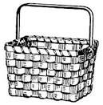

……………………………….…….  **(basket, saucepan)**

1. What do we call the young one of a cow?

…………………………………………………………………………

1. Why do we eat food?

…………………………………………………………………………

**to die,**  **to grow well.**

1. Draw **one** item used to keep the compound clean.
2. Name any **one** basic need of man.

………………………………………………………………………………………………………

1. Circle the animal found in the bush.

**lion, cow**

1. What do we call the place where people or animals live?

…………………………………………………………………………

**(home, school)**

1. Underline **one** thing that we eat.

**stones, bread**

**SECTION B.**

1. a) Give things a good home must have.
2. ………………………… ii) …………………………

**toilet, school, kitchen.**

1. 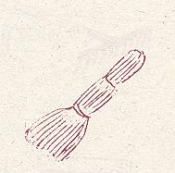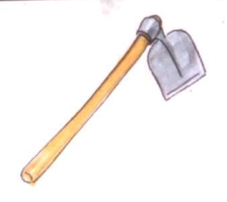Name these things we use to keep our home clean.

………………………………………… ………………………………………

**(hoe, broom)**

1. **Match these people to their roles.**

mother heads a family.

father fetch water.

children takes care of children.

1. Which name is given to the place where people or animals live? (**forest, home)**

………………………………………………………………………………………………

1. **Underline the animals found at home.**

goat elephant sheep

snake pig dog monkey

1. What are these buildings?

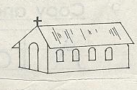 ………………………………………….

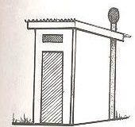………………………………………….

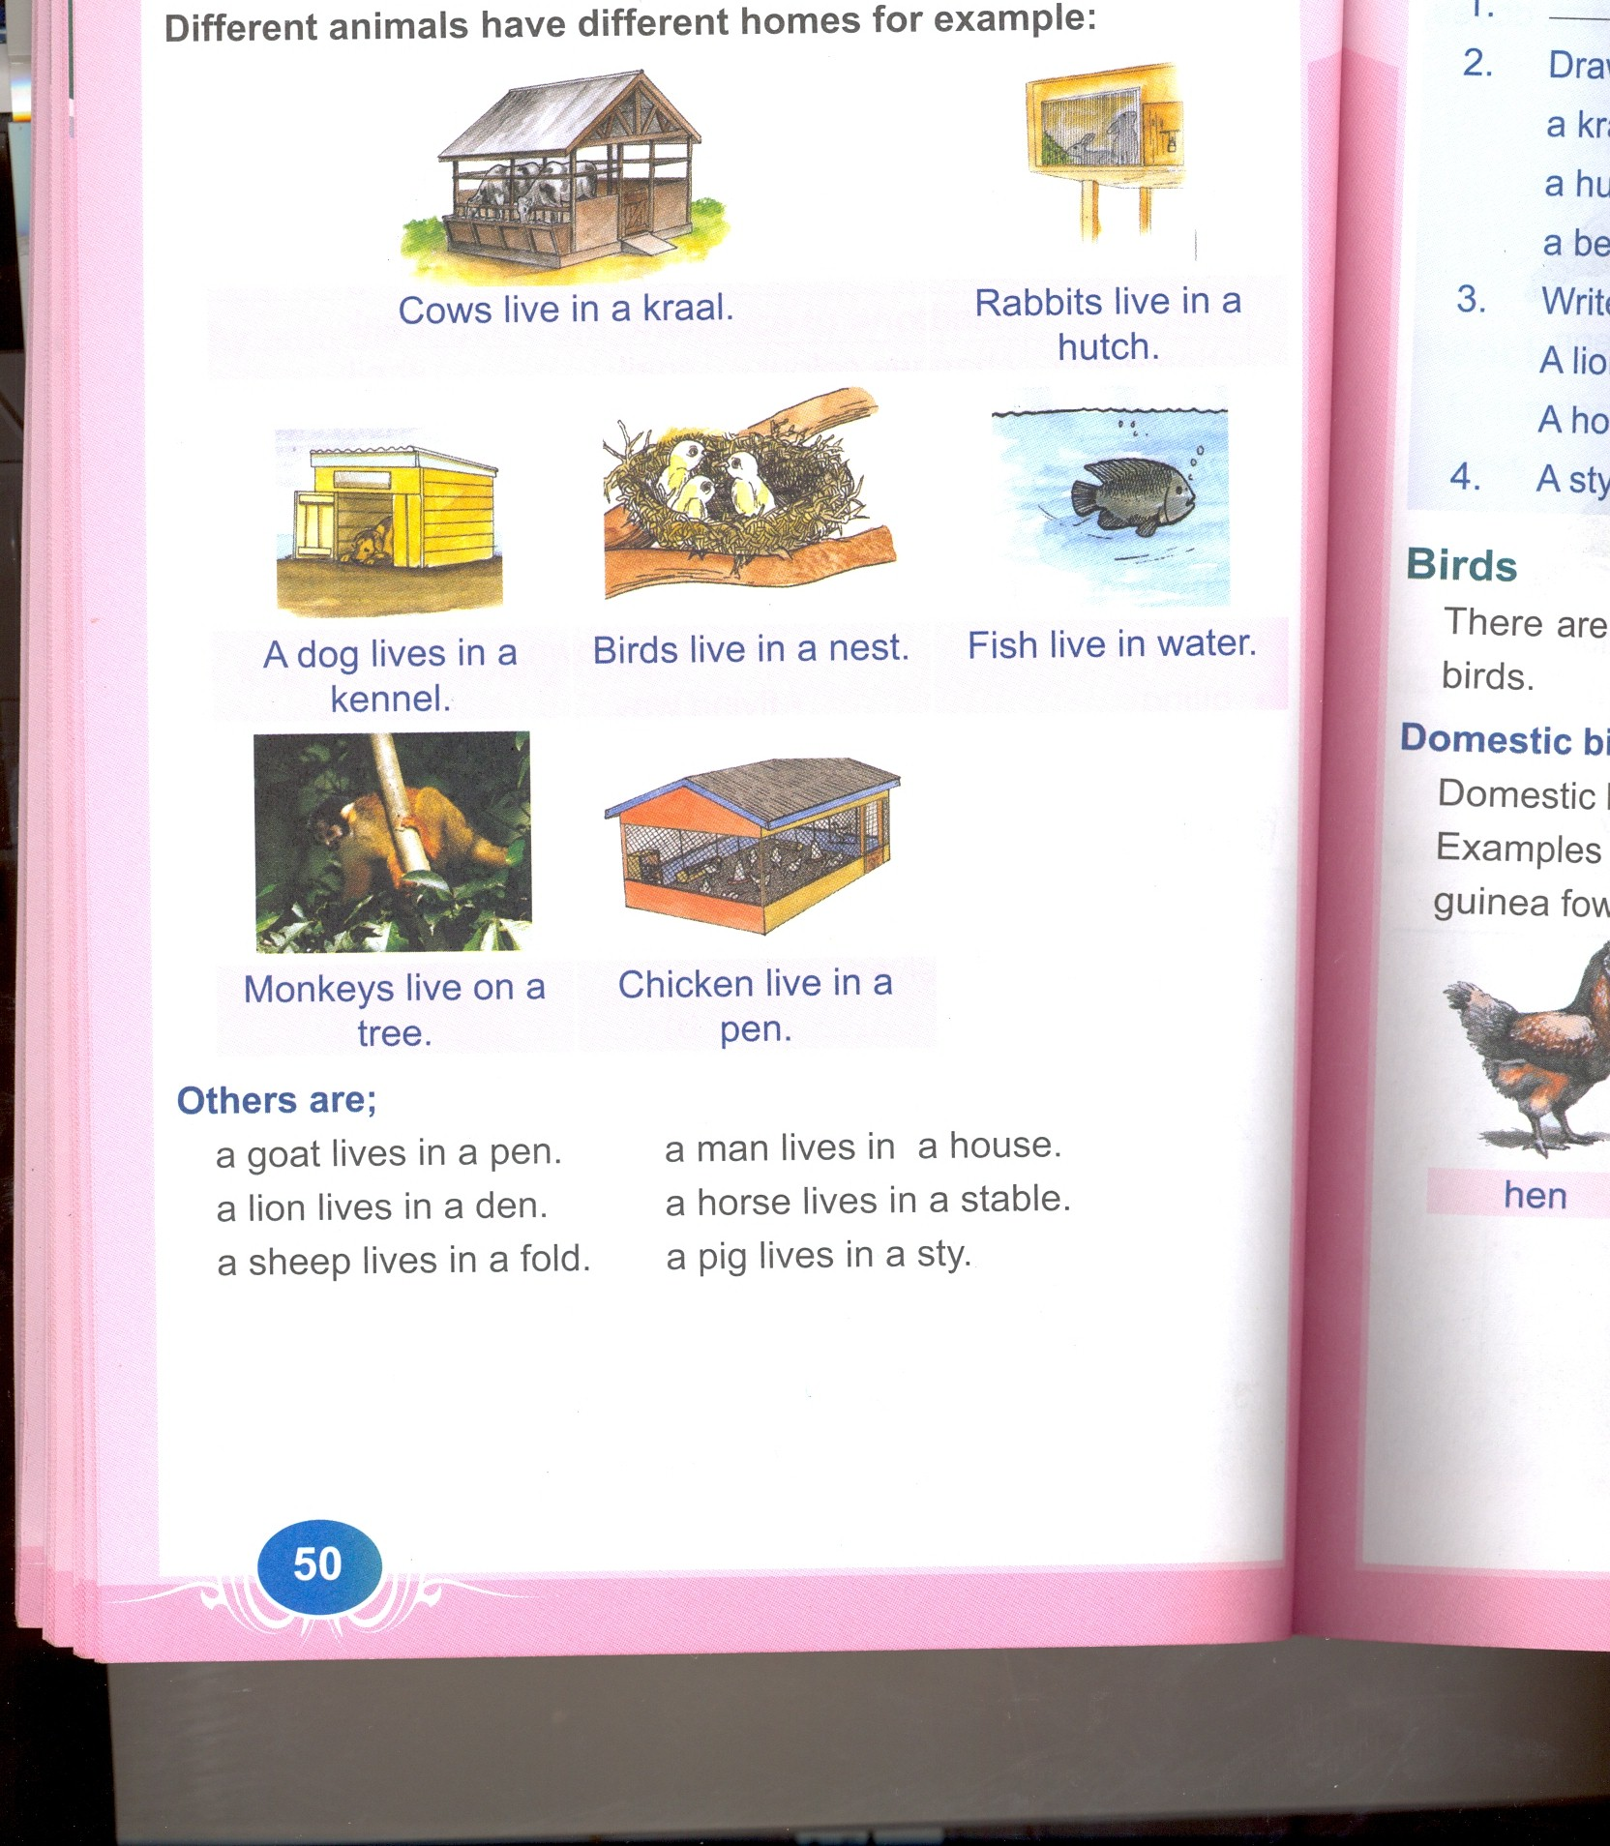………………………………………….

…………………………………………

**toilet/latrine, house, kitchen, kennel**

1. **Read and draw.**

|  |  |  |  |
| --- | --- | --- | --- |
|  |  |  |  |
| table | radio | television | chair |
|  |  |  |  |

1. **Underline the things found at home.**

hen school house

children kitchen pupils.

1. How do we call the home for;

pig: ………………………………………………………………………………………

a dog: ………………………………………………………………………………………

man: ………………………………………………………………………………………

cow: ………………………………………………………………………………………

**(kraal, house, kennel, pig sty)**

1. Match these items to their names.

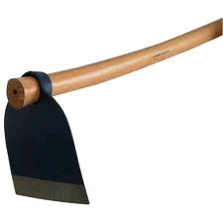axe

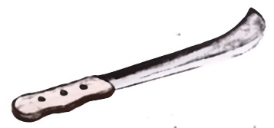

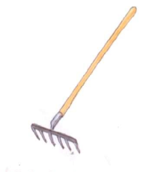rake

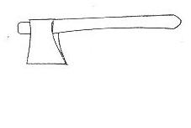hoe

panga

1. **Name these basic needs.**



………………………………………

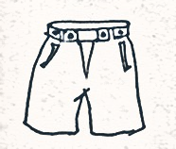

………………………………………

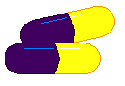

………………………………………



………………………………………

**(water, medicine, shelter, clothes)**

1. 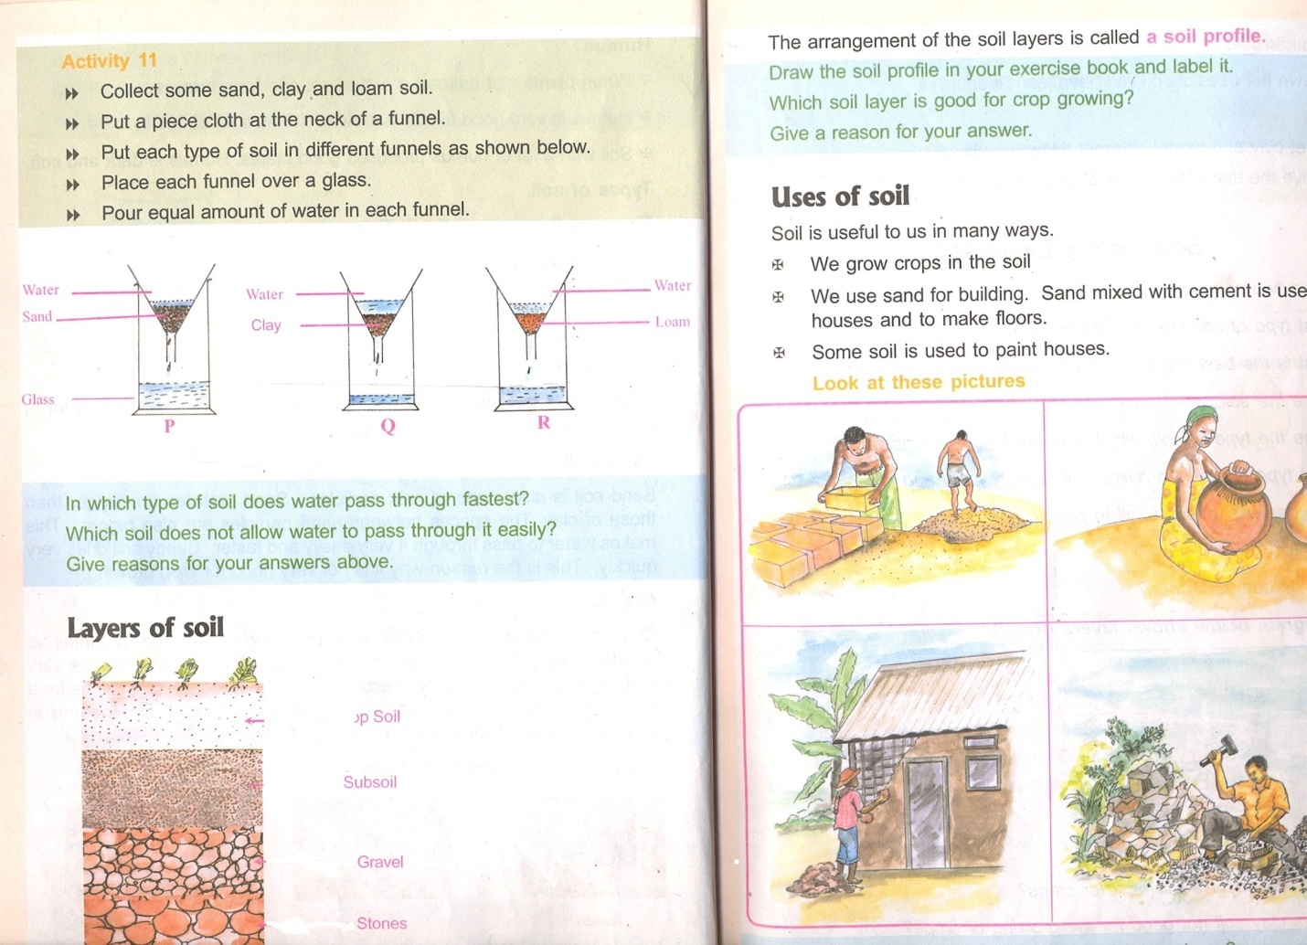**Match these building materials to their names.**

stones



bricks

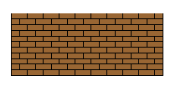

Iron nails

sand

1. 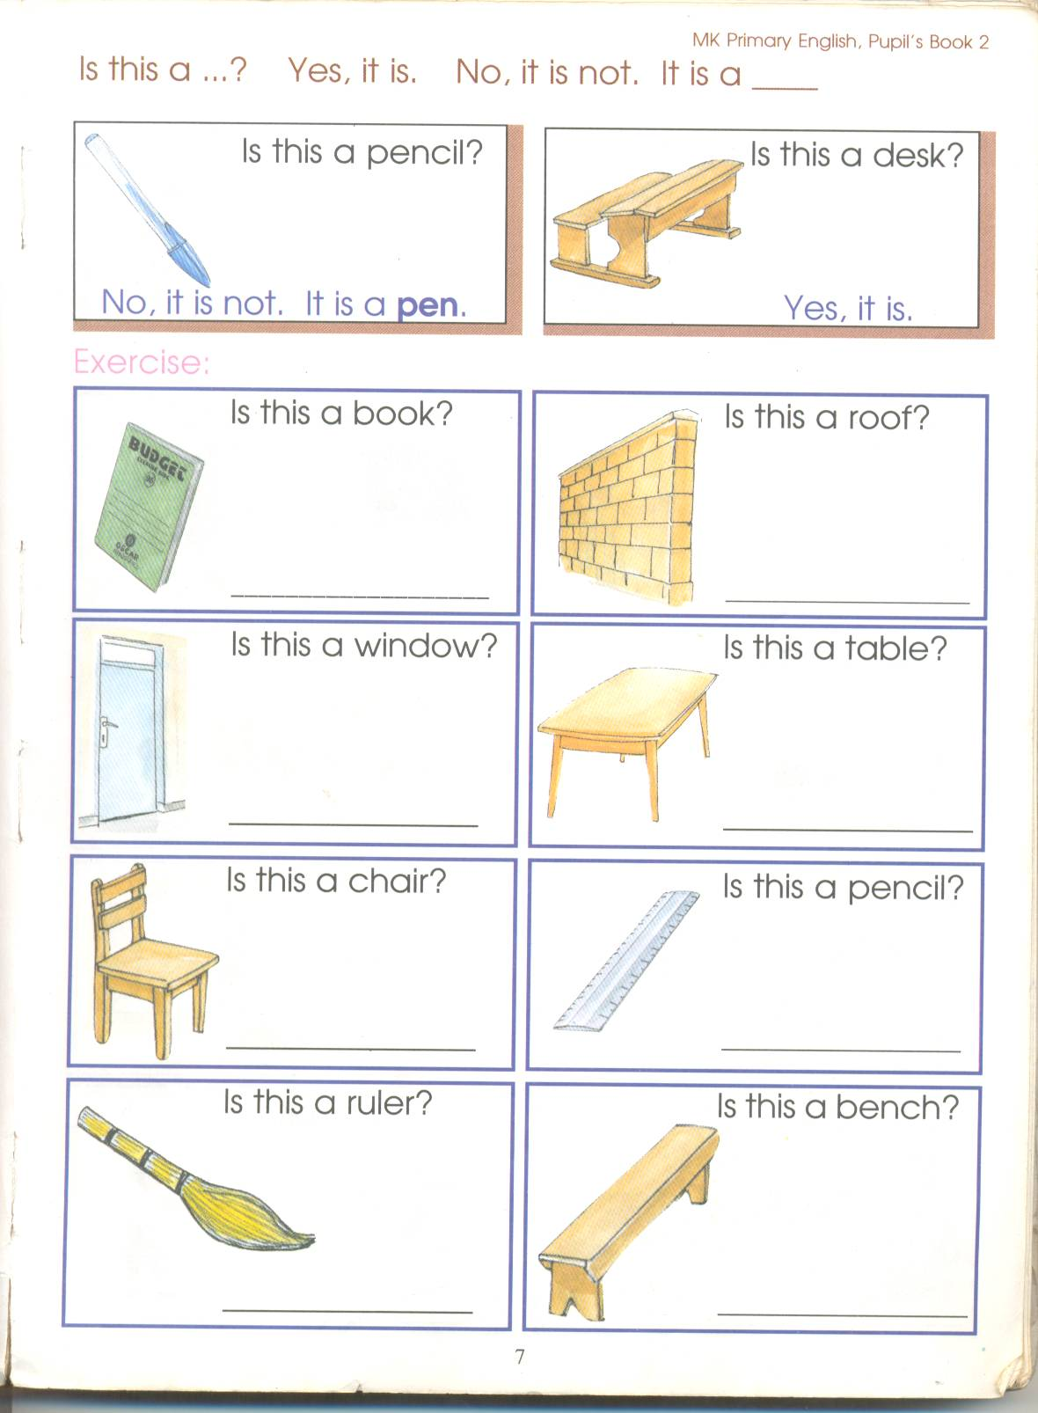Write the names of the following things used to keep our home clean.

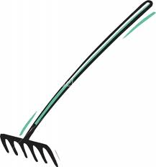

 …………………………………… ……………………………………

…………………………………… ……………………………………

**(broom, dustbin, water, rake)**

1. **Read and draw.**

|  |  |  |
| --- | --- | --- |
| **cow** | **goat** | **sheep** |
|  |  |  |

1. Mention any **one** reason for keeping animals at home.

…………………………………………………………………………………………………

1. 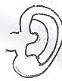What are these sense organs?

………………………………………………………

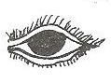

………………………………………………………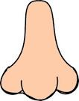

………………………………………………………

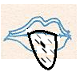

………………………………………………………

**(tongue, nose, ear, eye)**

1. Name these parts of house.

a

d

b

c

a: ……………………………………… b: ………………………………………

c: …………………………………. d: …………………..………………….

**(roof, wall, window, door)**

1. Give any **one** reason why we eat food.

………………………………………………………………………………………………………

1. Give another name for the following groups of food.
2. Body building food.

……………………………………………………………………………………………

1. Health giving foods.

……………………………………………………………………………………………

1. Energy giving foods.

……………………………………………………………………………………………

**(protein, carbohydrates, vitamin)**

**END**